CodeCrawler
Software Architecture Document

Version 1.3.6


Revision History
Date | Version | Description | Author
02/Nov/2004 | 0.1 | Initial version | Martin Mailloux
15/Nov/2004 | 0.2 | Version with the reviewers comments | Martin Mailloux
20/Nov/2004 | 1.0 | Update version with comments | Martin Mailloux
06/Dec/2004 | 1.1 | Updated version for homework5 | Martin Mailloux
08/Dec/2004 | 1.2 | Updated version for homework5 | Kinis Meyer
08/Dec/2004 | 1.3 | Accepted all the changes in 1.2, updated figure numbering, review with Kinis comments. | Martin Mailloux
08/Dec/2004 | 1.3.1 | Added component diagram and the new version of the deployment diagram from Mohan. | Martin Mailloux
09/Dec/2004 | 1.3.2 | Updated Future Deployment Diagram | Martin Mailloux
10/Dec/2004 | 1.3.3 | Updated the Use Case Diagram | Martin Mailloux
29/Apr/2005 | 1.3.4 | Updated for final report | Kinis Meyer
30/Apr/2005 | 1.3.5 | Added the performance results | Martin Mailloux
2/May/2005 | 1.3.6 | Reviewed changes and added some modifications | Nikolay Kojuharov

Table of Contents
1. Introduction 4
1.1 Purpose 5
1.2 Scope 5
1.3 Definitions, Acronyms and Abbreviations 5
1.4 References 5
1.5 Overview 5
2. Architectural Representation 6
3. Architectural Goals and Constraints 7
4. Use-Case View 8
4.1 Change Settings 9
4.2 Search & Perform Search- 9
4.3 View Source Code 10
4.4 Build Search Index 11
5. Logical View 12
5.1 Overview 12
5.2 Architecturally Significant Design Packages 13
5.2.1 Code Analysis Package (Façade) 13
5.2.2 Code Bank Package 14
5.2.3 Formatting Package (Façade) 15
5.2.4 Indexing 16
5.2.5 Lucene Package (Façade) 17
5.2.6 Search Package 18
5.2.7 User Interface Package (UI) 19
5.2.8 Utility Package (Global) 20
6. Process View 21
6.1 HttpServer 21
6.2 Presentation Layer 21
6.3 Indexing Process 21
7. Deployment View 23
8. Implementation View 25
8.1 Overview 26
8.2 Layers 26
8.2.1 Presentation Layer 26
8.2.2 Business Layer 26
8.2.3 Persistence Layer 26
9. Data View 27
10. Size and Performance 28
11. Quality 29
Software Architecture Document

Introduction
This document provides a comprehensive architectural overview of the CodeCrawler system, through RUP’s 4+1 View.
Large-scale software development and maintenance presents many challenges to developers. As the code base grows, so do the difficulties of staying up to date with the code, finding the right place for implementing new requirements, or trying to fix existing bugs. In addition, as code size increases, sometimes documentation does not get updated or is missing altogether, which makes training new developers difficult and time consuming.

When wandering through the code, developers often use grep utilities to find a particular piece of code. These utilities let developers search source files for a match with a regular expression, and while powerful, they have three disadvantages. First, writing a regular expression for a search necessitates at least some knowledge about what you are searching for – for example, the prefix of a variable name or that the variable ends with a number. Second, the results returned from a grep are all the matches to the given regular expression and in that respect are all equally relevant. This means a developer might get hundreds of results and have no idea which one to look at. Third, grep utilities are part of the operating system or are integrated within an IDE and the results cannot be viewed from the web. These days, when so many open source projects are developed over the Internet, searching source code directly from a web browser seems natural.

With the advancement of the Internet, web search engines have become irreplaceable tools for developers. Web search engines are not as precise and powerful as grep utilities, but address the grep utilities’ disadvantages. Web search engines allow inexact matches, rank the results by relevance, and display them in a web-viewable form. However, these search engines are usually geared toward text searches, and do not work well for source code.

In programming languages, identifiers usually combine several words (i.e. ListArray or basic_string), but to search engines a word is just a word, which is one of the drawbacks of search engines. If search engines were able to split an identifier into its composing words, then search engines would be more useful to developers and programmers. Search engines also compute a relevance score for a particular result based, in part, on how many occurrences of the search keywords appear in the results. In source code, however, there is an implied understanding that some occurrences are more important than others. For example, when searching for "Foo", a document with several occurrences of a local variable "Foo" is usually less relevant than a document declaring a class "Foo". Text search engines, of course, do not have the knowledge to perform this analysis. This lack of knowledge also means developers searching for a keyword with particular semantics; say function "Foo" might get results for class "Foo" or variable "Foo" or any other "Foo". A nice addition to the search engine query syntax would be to specify the semantics of the keyword being searched, for example, "function: Foo".

CodeCrawler will combine the best of web search engines and grep tools, and extend them with knowledge about programming language syntax and source code semantics to allow more intelligent searches that more accurately determine the relevance of search results. CodeCrawler will provide a web interface that allows users to submit search queries using regular expressions (like grep), using keywords (like web searches), or using special programming specific extensions.

The results returned from the searches will be ranked by relevance, taking into account source code semantics (class, method, variable, etc.), and will point to the original source code. The system will be easy to use, configurable, and responsive. CodeCrawler will support as many programming languages as possible, and will be easily extendable with support for new programming languages.

The users of CodeCrawler are expected to be software developers and programmers familiar with the syntax of at least one programming language and regular expressions. CodeCrawler requires an administrator to maintain the indexes and connections for accessing the source code.

Purpose
This document provides a comprehensive architectural overview of the system, using a number of different architectural views to depict different aspects of the system. It is intended to capture and convey the significant architectural decisions, which have been made on the system. This document provides the basic knowledge on the overall design structure and also the deployment capability of the CodeCrawler software.

Scope
This document provides the architectural overview of CodeCrawler. CodeCrawler automates the process of retrieving sources file to index them and provides a web based user interface to expose “source” aware search functionality.

Definitions, Acronyms and Abbreviations
See Code Crawler Glossary

References
Code Crawler Project Proposal

Code Crawler Requirements

Code Crawler User Cases

Overview
The main organization of the document is based on RUP’s 4+1 Architectural Views. One section per view describes the CodeCrawler implementation and their major impact on the overall architecture.

Architectural Representation
Our software architecture is based on a multi-layer architecture developed in Java with external package in C++ and Java. For the first release, all of the tiers will be implemented under Tomcat. Future releases could provide greater scalability by using many Java Virtual Machines, one per major function (Search, Indexing, etc.). The Search could also be scaled by using many instances of the Java Virtual Machine on many physical servers. Our goal is to provide a “source” aware search engine, to be used by one development team, therefore such a scalability will probably be quite sufficient.

Architectural Goals and Constraints
Security: the only security issue currently, is the stored username and password to access an external codebank. In version 1.1, encryption with a secret key will be used (Triple-DES) to store the information in an XML file. Currently, the information is in plain text in the configuration file.
Portability: our portability will be limited to the portability of our external packages (Ctags, Highlight).
Distribution: our first release will be available only for Windows 2000 and XP. Other platforms could also be supported, but we will only test on these two platforms.
Constraints: the external packages will limit which platforms/languages we can support.
Performance and accuracy are CodeCrawler’s main factors of success. Providing a source search, instead of a plain textual search, is our main goal.

Use-Case View
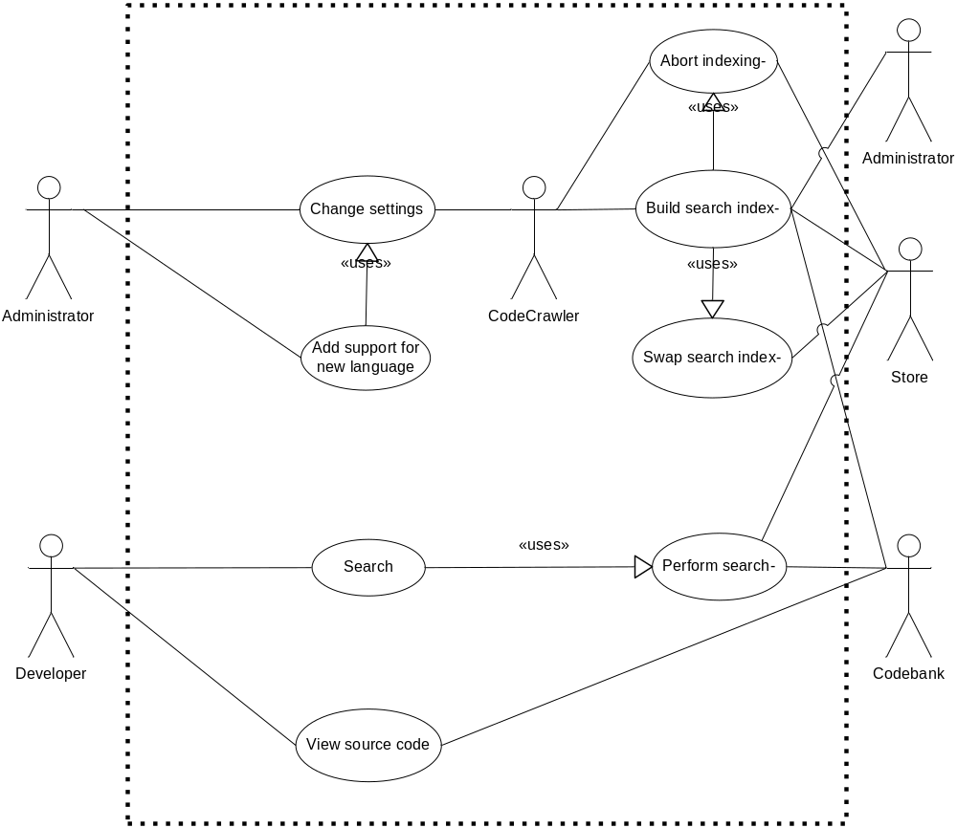
Figure 1. Use Case Diagram

Change Settings
The administrator logs in and modifies some configuration settings. The system picks up the changes and updates its state and behavior appropriately.

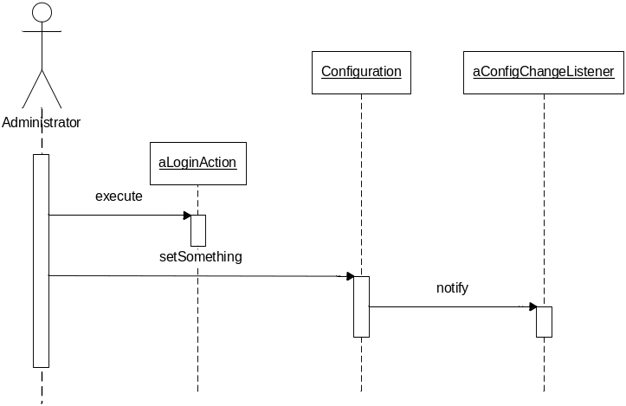
Figure 3. Change Setting Diagram

In version 1.0, aLoginAction is handled by Tomcat through logging into the servlet with a username with an administrator’s role to make any configuration changes to CodeCrawler.

Search & Perform Search-
A developer submits a search query. The system parses and validates the query, and then searches the index for matches to the query. Any matches are scored and then a results page is built. For each result, the page contains a highlighted code snippet as well as some file information such as file size, name, last modification date, etc. The results are then displayed to the developer.
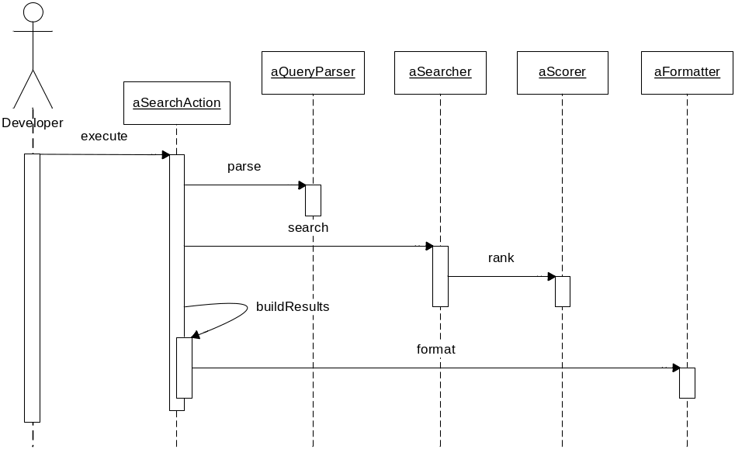
Figure 4. Search & Perform Search Diagram

View Source Code
A developer clicks on a result link in the results page, which submits a request to view the code for that result. The system fetches the requested file, formats it to HTML, and displays it to the developer.
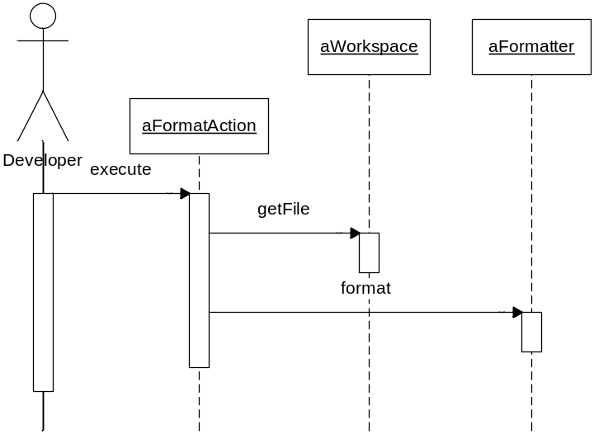
Figure 5. View Source Code Diagram

Build Search Index
The system scheduler (configured by the administrator) notifies the system that it should start indexing. The indexer fetches source files from the codebank, analyzes them for source tag information, and adds them to the search index. After the task is finished, the indexer notifies the monitor which, in turn, notifies the administrator of any errors or the success of the operation.
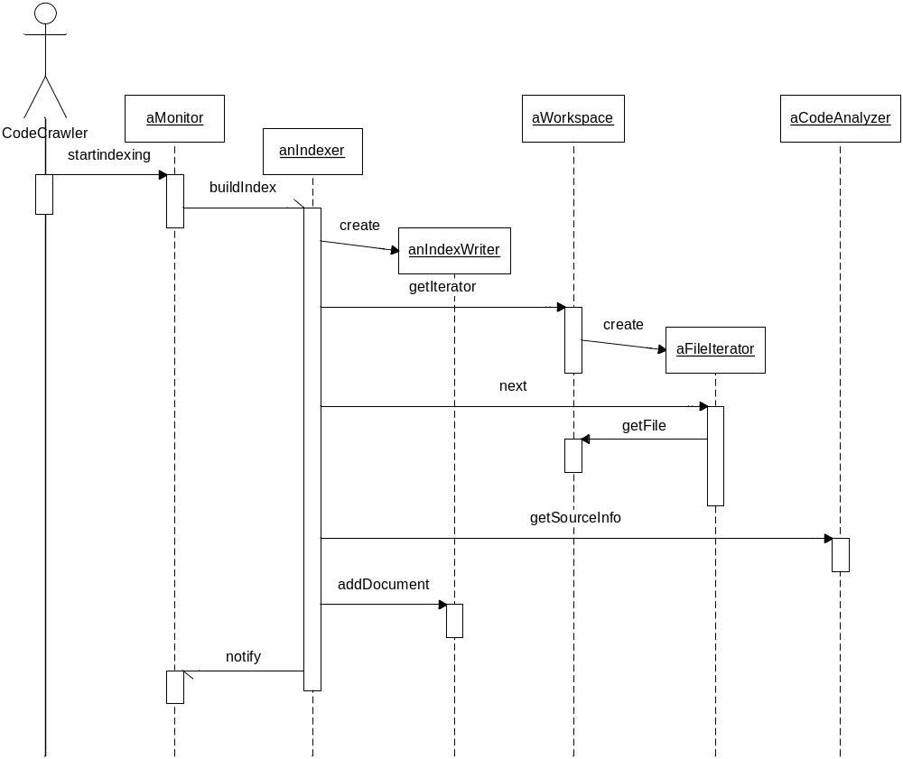
Figure 6. Build Search Index Diagram

Logical View
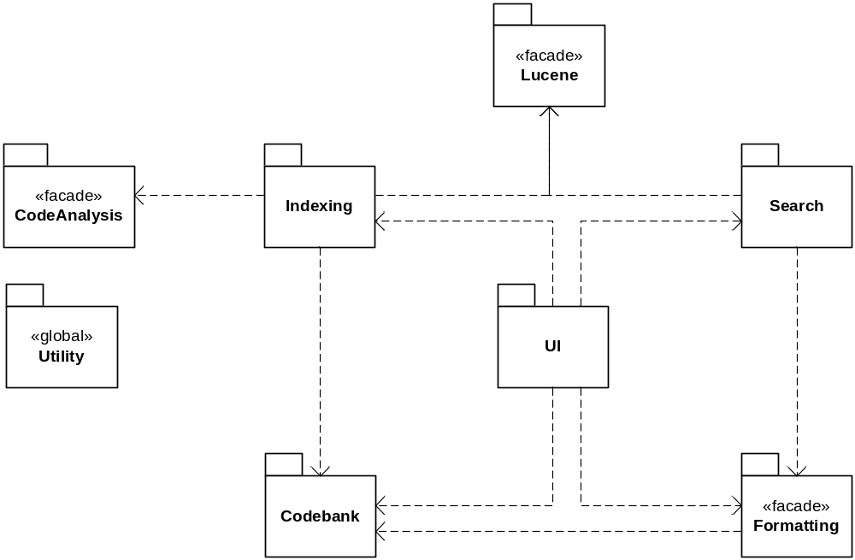
Figure 7. CodeCrawler Package Diagram

Overview
Name | Description
Code Analysis | Provides classes for analyzing source files to extract the context of the ‘words’ in the source files in order to have a ‘source code’ search engine, not only a textual search engine. Using code analysis allows support for queries like “method:foo”, that return source files having a method named foo, not only sources with the text foo.
Code Bank | Provides the abstraction to how CodeCrawler will obtain the source files. Implements gateways to different storage systems (CVS, file system, web, database, archives, etc.).
Formatting | Provides utilities for converting source code files to a web displayable format using syntax highlighting.
Indexing | Implements classes for controlling and performing the indexing process.
Lucene | The Lucene package is a third party framework for building textual search engine (open source project Lucene http://jakarta.apache.org/lucene/docs/index.html). CodeCrawler extends this framework in the Indexing and Search packages to develop a source code search engine.
Search | The Search package includes all of the classes to implement CodeCrawler’s search functionality.
UI (User Interface) | The UI package will include all of the classes used to implement the web interface. The user interface will be based on the Servlet API.
Utility | The Utility package will include all common classes, such as the configuration reader, that may be used by many of the packages.

Architecturally Significant Design Packages

Code Analysis Package (Façade)
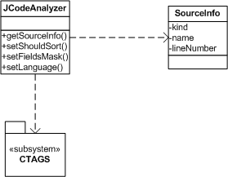
Figure 8. Code Analysis Class Diagram

The Code Analysis package provides classes for analyzing source files to extract the context of the ‘words’ in the source files in order to have a ‘source code’ search engine, not only a textual search engine. Using code analysis allows support for queries like “method:foo”, that return source files having a method named foo, not only sources with the text foo in them.

Name | Description
CTags | CTags is an open source project (http://ctags.sourceforge.net/) which will provide parsing and context analysis of source code.
JCodeAnalyzer | A gateway to the Ctags package.
SourceInformation | A class used to store the context information returned by JCodeAnalyzer.

Code Bank Package
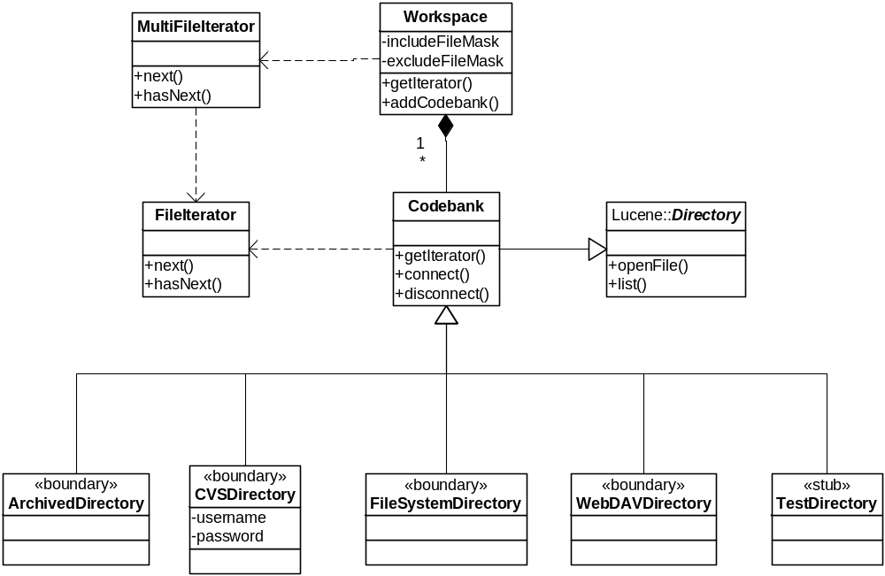
Figure 9. Code Bank Class Diagram

The Code Bank package provides the abstraction to how CodeCrawler will obtain the source files. The package implements gateways to different storage systems such as CVS, file system, web, database, archives, etc.

The system has in its configuration a “Workspace”, which may have many “Codebanks”. A codebank is a physical location where the sources are stored.

Name | Description
ArchivedDirectory | A class to provide access to an archived directory (zip, jar).
CVSDirectory | A class to provide access to a directory through a CVS (Source Manager) access.
Codebank | A configuration on how to retrieve the sources from a physical location
FileIterator | Helper class to access a directory’s files through a Java enumerator.
FileSystemDirectory | A class to provide access to sources on a file system.
MultiFileIterator | A Workspace can have many Codebanks. This class iterates over the file iterators of all Codebanks in that Workspace.
TestDirectory | A class to provide a testing implementation.
WebDAVDirectory | A class to provide access to a directory through a WebDav implementation (http://www.webdav.org/).
Workspace | Represents a logical grouping of multiple Codebanks.
TempCodebank | A temporary codebank is created to allow archived codebanks a root to be expanded under for indexing and iterating over. The temporary directory is deleted to cleanup on exit.

Formatting Package (Façade)
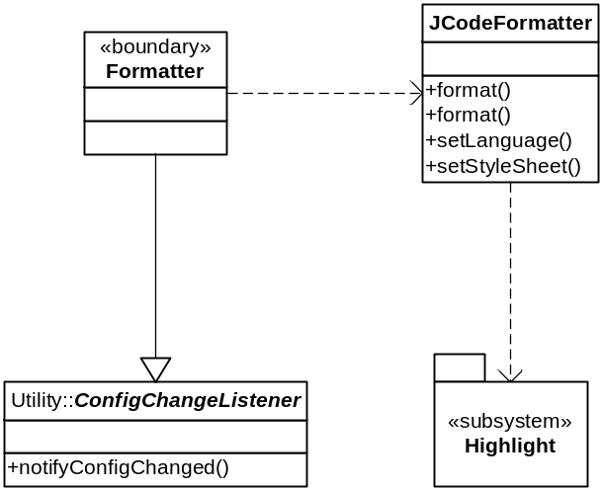
Figure 10. Formatting Class Diagram

The Formatting package provides utilities for converting source code files to a web displayable format using syntax highlighting.

Name | Description
Highlight | A third party package which converts source code into syntax highlighted HTML using color schemes and CSS.
Formatter | A class servicing user requests to ‘browse’ source code online (see the View Source Code in the Use Case Model).
JCodeFormatter | A gateway to the Highlight package.

Indexing
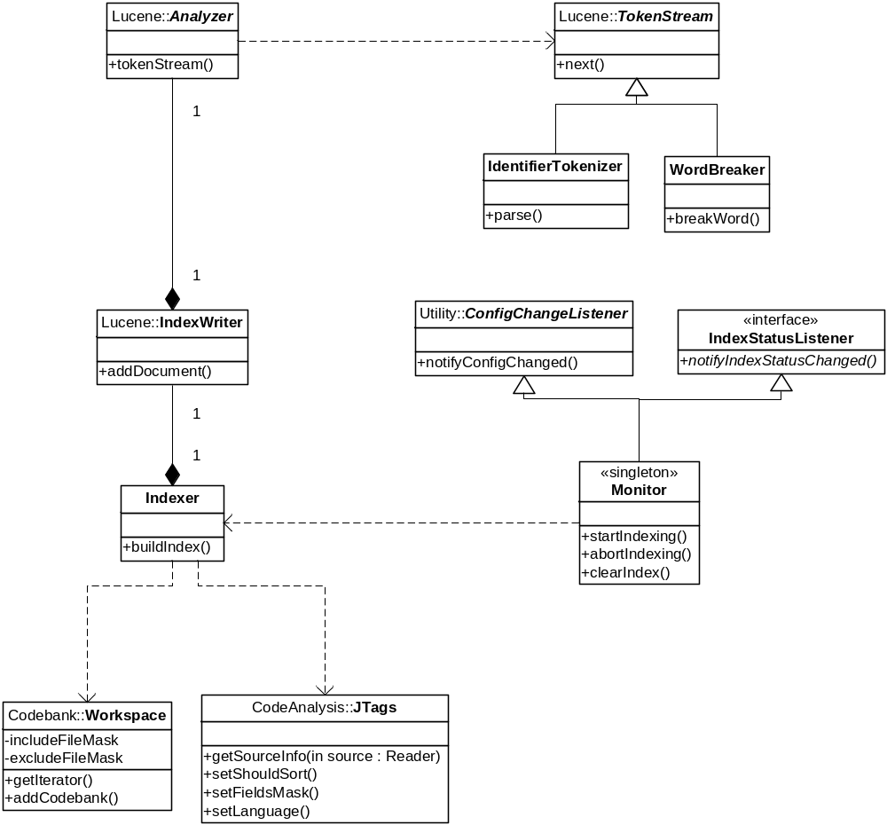
Figure 11. Indexing Class Diagram

Name | Description
Indexer | Implements the process to retrieve the sources and to index their contents.
IdentifierTokenizer | Generates a stream of tokens from source code.
Monitor | Implement the scheduler to start, stop, and monitor the indexing process.
WordBreaker | Breaks tokens written in mixed case or with underscores into multiple words (e.g. FooBar or fooBar or foo_bar will result in “foo” and “bar”).
IndexStatusListener | An interface for observing changes in the indexing status

Lucene Package (Façade)
This package is a third party framework which CodeCrawler builds upon and extends. The class diagram sketches the most important classes in the package without modeling the whole framework. For description of the classes, see Lucene’s documentation at http://jakarta.apache.org/lucene/docs/api/.

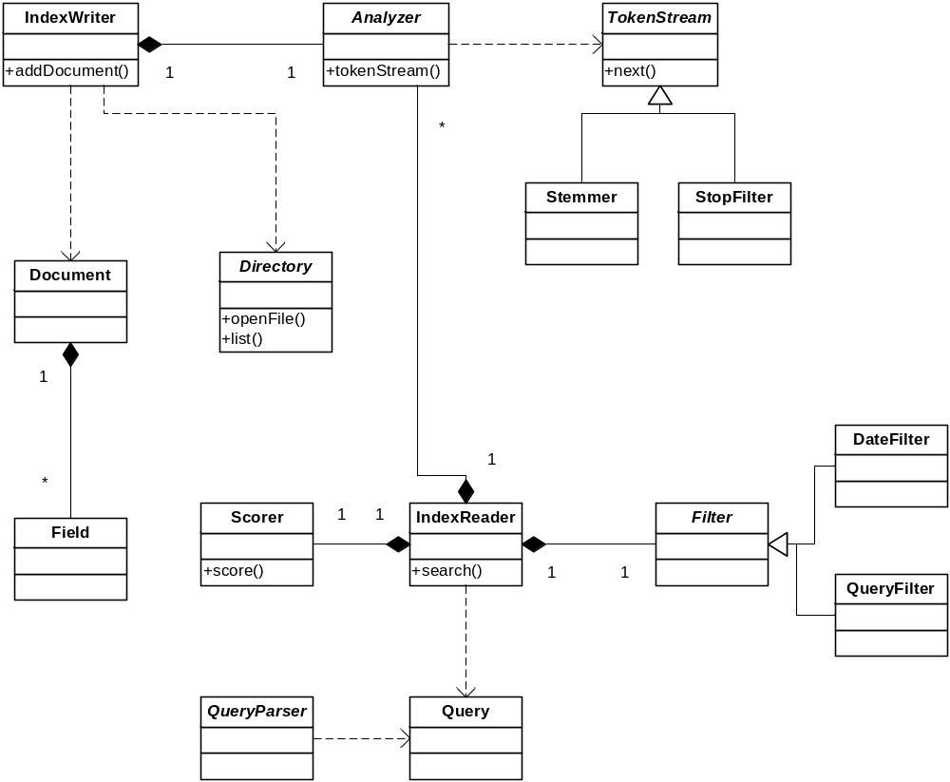
Figure 12. Lucene Class Diagram

Name | Description
Analyzer | Process a source file to extract its words.
IndexWriter | Lucene’s IndexWriter class. It provides the management of the index contents.
TokenStream | Provides the tokenization of a source file.
Stemmer | Implementation of the Stemming algorithm.
StopFilter | Removes the stop words from the source.
Document | Lucene’s document. In CodeCrawler’s context, it is a source file.
Directory | Source file’s location.
Field | A keyword which can be used to search for a source.
Scorer | A subclass of Lucene::Scorer implementing CodeCrawler’s context sensitive relevance ranking algorithm.
IndexReader | Lucene’s IndexReader. It provides the access to Lucene’s Index.
Filter | A subclass of Lucene::QueryFilter implementing CodeCrawler’s filtering behavior.
DateFilter | A specialization of the Filter class, to filter on date. (Moved to version 1.1 implementation)
QueryFilter | A specialization of the Filter class to filter on a set of criteria.
Query | An object representation of the search criteria.
QueryParser | A subclass of Lucene::QueryParser implementing a parser for CodeCrawler’s search query syntax.

Search Package
The Search package includes all the classes to implement CodeCrawler’s search functionality.

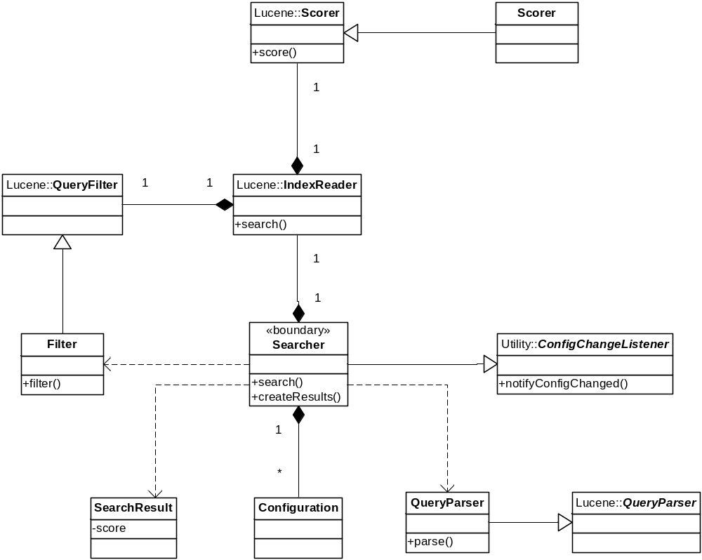
Figure 13. Search Class Diagram

Name | Description
SearchResult | Provides an encapsulation of the search result provided by Lucene.
Searcher | Performs the search process based on the user’s criteria.
Filter | A subclass of Lucene::QueryFilter implementing CodeCrawler’s filtering behavior.
Scorer | A subclass of Lucene::Scorer implementing CodeCrawler’s context sensitive relevance ranking algorithm.
QueryParser | A subclass of Lucene::QueryParser implementing a parser for CodeCrawler’s search query syntax.

User Interface Package (UI)
The user interface will be implemented using servlet with a separation of the processing using the Model/View/Controller pattern.

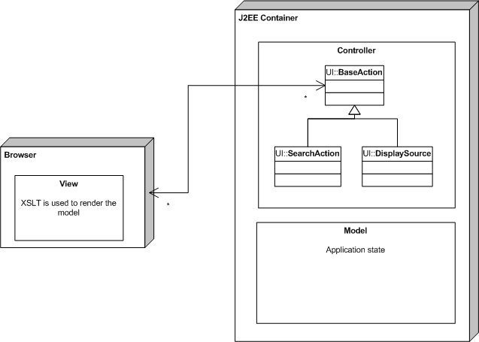
Figure 14. Model-View-Controller Diagram

Model - The model represents enterprise data and the business rules that govern access to and updates of this data. Often the model serves as a software approximation to a real-world process, so simple real-world modeling techniques apply when defining the model.

View: The view renders the contents of a model. XML/XSLT will be used to produce the rendering for the user interface on the user’s browser. Therefore, under the Model/View/Controller pattern, the View will be rendered by the user’s browser.

Controller: The controller translates interactions with the view into actions to be performed by the model. One specialized servlet will be used to process the GET and POST HTTP requests and convert them to the object model object to be processed. Based on the requested action and its outcome, the controller will specify the XSLT template to be used in the XML document transmitted to the browser.

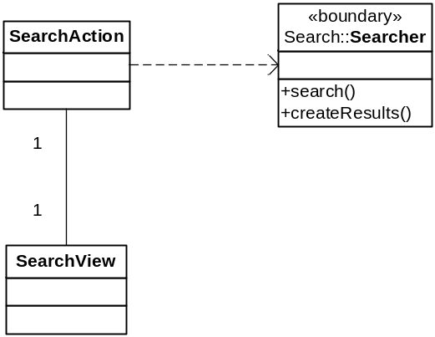
Figure 15. UI (Search) Class Diagram

Name | Description
SearchAction | Provides the implementation to Filter some sources based on the user’s criteria. The same class could implement basic search, advanced search, and continue search (for displaying next page of results).
SearchView | Parses the user’s query to provide a Lucene’s query.

Utility Package (Global)
The Utility package will include all common classes, such as the configuration reader, that may be used by many of the packages.

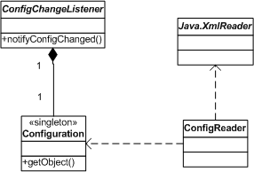
Figure 16. Utility Class Diagram

Name | Description
ConfigReader | Generic class to provide the access to the configuration information.
Configuration | Class to ‘objectize’ the configuration. It also provides the abstract factory to instantiate the system object.
ConfigChangeListener | An abstract class implementing an observer of changes to the configuration
JavaXMLReader | A utility class to read and convert the XML configuration file into an object representation.

Process View

HttpServer
The first implementation uses the HttpServer provided by Tomcat. This provides an easy development platform, without impacting the deployment capability on any HttpServer-Servlet implementation.

Presentation Layer
The Servlet API provides two types of servlet:
- SingleThreadModel, which instantiates a new instance for each request, and
- Default model, Shared, where the servlet is a singleton shared by all the threads used to process the request.
The default model, Shared, will be used in CodeCrawler’s implementation. The business layer is invoked directly through method invocation in the same Java Virtual Machine, therefore having the business and presentation layers sharing the same thread.

Indexing Process

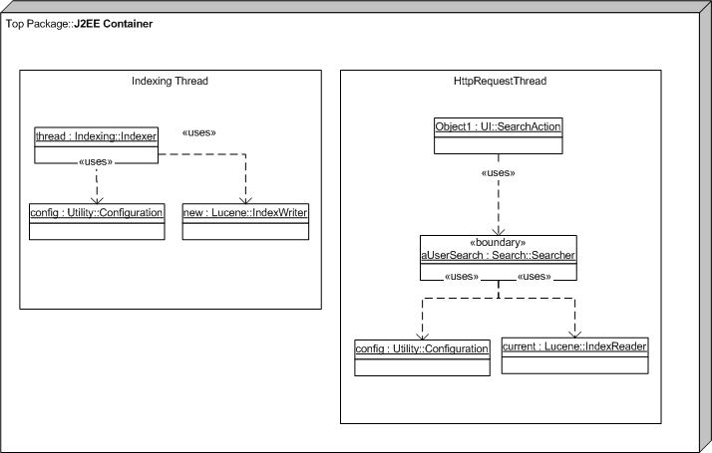
Figure 17. Indexing Process Diagram

The Indexing process is implemented using a “startup” servlet, which uses a Monitor object which controls the scheduling of events. Once an indexing event is signaled, the Monitor launches an Indexer which builds the search index based on the system’s parameters. Upon completion, the Indexing process locks the existing search index exclusively and replaces it with the newly built one. Once the exclusive lock is released, all searches will begin using the new index.
The first implementation will require executing the Indexing process on each instance of the Tomcat-Search JVM to manage the events between each other. Future implementations will support distributed processing and events management across JVM. Future releases will support the retrieval of sources through a set of Source Retrievers which will execute on different threads than the Indexing process itself.

Deployment View
The first implementation will execute all the online and batch processing under the same Java Virtual Machine, under Tomcat. In the design, the integration point between the presentation layer and the business layer must support the adding of a remote invocation between the layers without requiring an overhaul of the design and only affect the implementation of very few methods. Only the codebanks in the current implementation can be accessed remotely to generate the index.
Optimally in future releases, the HttpServer, Servlet Engine, and the Search Engine could be installed on different servers using remote call. Also, the indexing process could be executed on a different physical server with a distribution of the new index to the search engine.
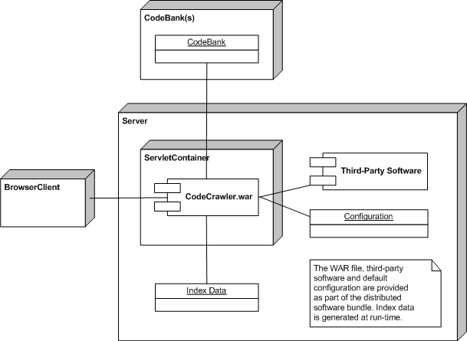
Figure 18. First Release Deployment Diagram

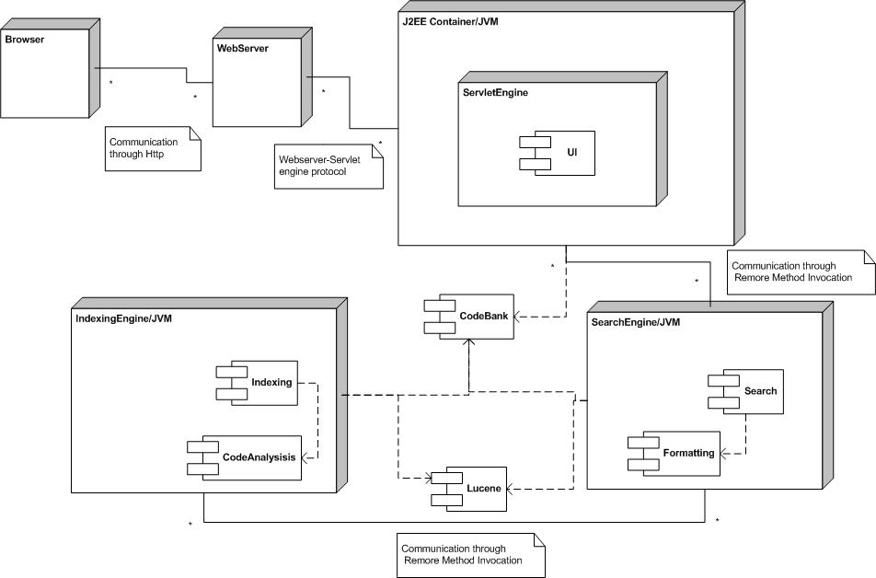
Figure 19. Future Release Deployment Diagram

Implementation View

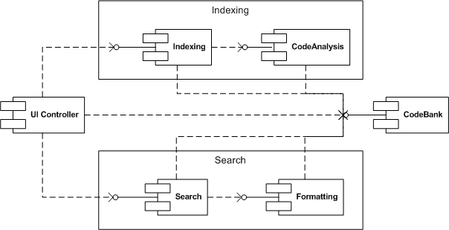
Figure 20.Component Diagram
CodeCrawler’s architecture is based on 3 tiers architecture: Presentation, Business, and Persistence.
The complexity of CodeCrawler’s software is within the business layer, and more precisely to provide the indexing mechanism and to search for a source file.
CodeCrawler uses many open source projects:
- Lucene: is an indexing and searching engine used to search documents. It provides an sdk that allows a programmer to index and search various documents. A parser object parses a source file and creates a document. This document is then searchable by field, such as title, filename, contents, etc..

- CTAGS: http://ctags.sourceforge.net/, is used, mostly, to provide a way to browse code for source code editors such as vi or emacs. It does this by creating a text index to represent the code. The plan is to integrate the index into the one created by Lucene. Ctags supports a wide range of programming languages out of the box and can be easily extended to support more.
- Highlight: http://www.andre-simon.de/doku/highlight/highlight_bsp_en.html, is a tool that highlights programming language code. It does this by creating an HTML representation of the code. Since this is an HTML representation, it is ideal for browsing and displaying the results of searches. The languages supported by Ctags and highlight overlap but not completely.

- Tomcat: servlet implementation and web server.

Overview

Layers
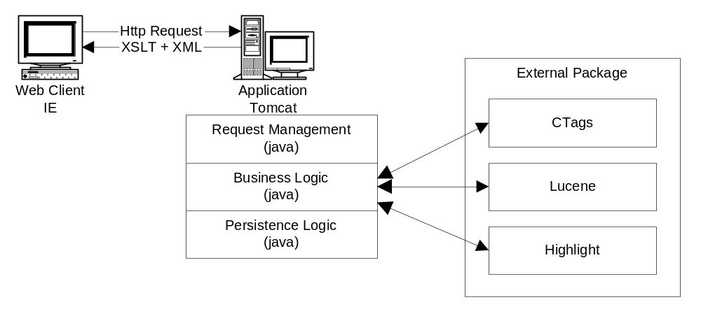
Figure 21. Layers Diagram

Presentation Layer
The presentation layer is divided in two types of classes:
- the Action that provides the processing of the request and
- the View that provides the generation of the XML.
CodeCrawler does not dynamically generate HTML, instead the browser capability is used to render an XML document through an XSL template. The presentation layer therefore receives an Http request, transmits the request to an Action class, which interfaces with the business layer to retrieve the results. The results are then processed by the View prior to sending the XML document to the user’s browser.

Business Layer
The business layer provides all the business processing required to handle the request and to provide the results. It also handles the indexing process, which involves retrieving the sources and processing the file for their indexing.

Search
The search provides all of the functions to efficiently search for sources. The search is stateless, with all the required parameters to re-execute the search to provide adequate paging of the results.

Source Highlighter
Source highlighter provides highlighting of the source code, similar as in most IDEs.

Source Processor
Source processor provides the source files’ processing to analyze their contents, and provides context to the word in the source.

Persistence Layer
CodeCrawler’s software does not have a “rich” persistence layer. Only the configuration management requires access to external files, which are stored in text/XML format. Lucene’s index is stored and managed through Lucene’s components.

Data View
CodeCrawler does not have complex data storage.

Input:
- Most configuration information will be stored in XML files on the local file system.
- The index information is managed by Lucene and is also stored on the local file system.
- Search criteria are through a web interface or SOAP.

Output:
- Lucene’s index structure.
- Search results, through a web interface or SOAP.

Size and Performance
Like all search functions, performance with recall and precision are some of the most critical criteria. The indexing process itself must provide adequate performance to support indexing for an average size project within an hour on a low-end workstation and searching in less than one second.

Performance TestCase
Test Case  # | Source | Description | Size Compressed | Size  Uncompressed | # files
1 | TestFiles | Code Crawler’s test files |  | 848k | 202
2 | HttpUnit | Sources of Http Unit project1.6 | 3050k | 6298k | 355
3 | Xerces | Sources of Xerces 2.5.0 | 2478k | 8480k | 788
4 | Tomcat | Sources of Tomcat 5.5.9 | 5965k | 19306k | 2565

Performance: to evaluate the disk requirements to index different codebanks’ sizes.
Size
Project size | Test Case | File to processed | Uncompressed  Source size | Index size
< 500 sources | 1 | 202 | 848k | 508k
>500 <2000 | 1,2,3 | 1345 | 15626k | 18.9m
>2000 <10000 | 1,2,3,4 | 3910 | 34932k | 46.1m

Performance: to evaluate the time required to index a codebank and the effect of the codebank’s size on the response time on a low-end and a mid-range workstation.

Low-end: IBM Thinkpad, Pentium 600Mhz,

The server and the client were running on the same computer.
Low-End
Project size | Indexing time  (sec) | Single term search time  Single User  (faster, average, max in ms) | Single term search time  Five Users  (faster, average, max in ms)
< 500 sources | 11 | 121, 121, 952 | 120,877,2133
>500 <2000 | 294 | 200, 685, 4787 | 241,950,1993
>2000 <10000 | 798 | 180, 730, 5017 | 460,1155,2103

Mid-range: Compaq Desktop, Pentium 2.4Ghz,

The client and the server and the client were running on different computer.

Mid-Rance
Project size | Indexing time  (sec) | Single term search time  Single User  (faster, average, max in ms) | Single term search time  Five Users  (faster, average, max in ms)
< 500 sources | 5 | 90,319,561 | 120,877,2133
>500 <2000 | 94 | 90, 360, 1973 | 90,890,2434
>2000 <10000 | 227 | 90,423,2010 | 100,960,2784

Quality
This document provides the architectural overview of the system used to retrieve and index sources that will be searchable from a web based user interface.

Extensibility: CodeCrawler’s extensibility is limited for some functions by the external packages used in the implementation. The major components are accessed through the “Factory” pattern, which allows them to be replaced by only changing the configuration.

Reliability: CodeCrawler’s architecture is based on well-known components with excellent track records for uptime and robustness.

Portability: Since the implementation is in Java, it is very portable; CodeCrawler’s portability is limited only by the supported platforms of our external packages.

Scalability: The first implementation will support scalability, by having many instances of Tomcat/Search engine running and through dispatching requests to the many Tomcat/Search engines. Solutions are already available to support “farming” of the web server, which is compatible with CodeCrawler’s implementation. CodeCrawler’s search function is stateless, therefore allows the “roaming” of the request amongst the web servers.

A risk spreadsheet has been maintained and identifies project risks and their severity.

To date, several of the risks have been eliminated, and others have been mitigated. A serious risk, #20- Scoring algorithm may be too complex, has not yet been mitigated. Action must be taken to clarify the nature of this risk, and find a way to mitigate it. It has to do with the scoring algorithm, which must be further elaborated to deal with this risk.

